**Deliverable 3**

1. **Overview of the analysis**: Explain the purpose of the new analysis.

ANALYSIS OVERVIEW

Displaying ride-sharing services data for 3 city types; Rual, Suburban and Urban. The data will be used to for future-decision making to determine any opportunities to implement ride-sharing services to underserved neighborhoods.

1. **Results**: Using images from the summary DataFrame and multiple-line chart, describe the differences in ride-sharing data among the different city types.

RESULTS

For the 3 city types; Rual, Suburban and Urban, snapshot summary of total of rides, total drivers, and total fares. Also includes the average fare per ride and average fare per driver. Another snapshot showcasing the total fares by week.

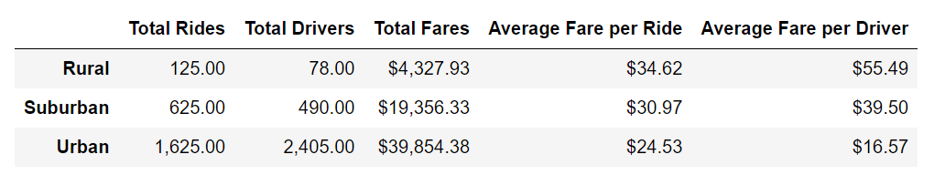

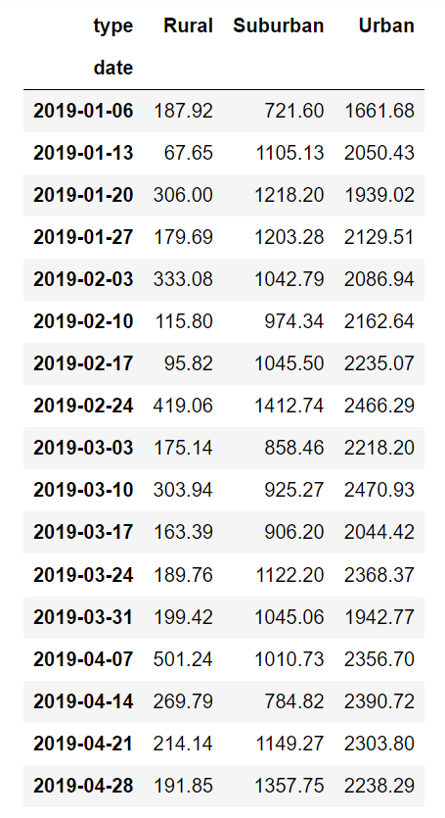

*Urban*

Comparing the visual summaries, the averages, the total amount of drivers and fares in urban areas are significantly higher due to the expected high population deriving a mix of residential and business populations.

*Rual*

Rual areas have a lower population and are characteristically less developed compared to urban areas having the lowest averages and overall, the lowest total amounts of drivers and completed rides.

*Suburban*

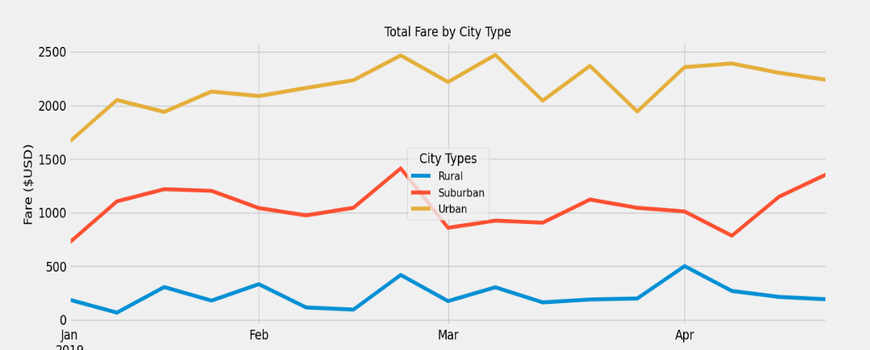Suburban areas are just between urban and rural areas. Reviewing the weekly sample visual summary for each city type, supports the average summary analysis.

1. **Summary**: Based on the results, provide three business recommendations to the CEO for addressing any disparities among the city types.

SUMMARY

Since there is a larger population in urban areas, the demand for ridesharing services is essential. I recommend a steady flow of available drivers to satisfy the demand for ridesharing services with the awareness of a lower average fare per driver.

However, a driver will have a higher average fare per ride in rural areas but the demand for rides are not as high as urban areas and will have more down time waiting for the next requested ride. I recommend minimal ride sharing services in rural areas.